FAMILY PLEDGE FORM: Belleville Christian School 2 km, 5 km SPIRIT RUN 2016
Saturday June 4, 2016, 138 Wallbridge-Loyalist Rd. & Quinte Conservation Area
Please list each participant’s name: _________________________________________
____________________________ _____________________________ _____________________________ (Family Name)
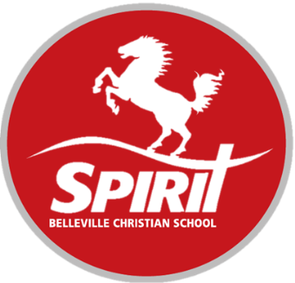
____________________________ _____________________________ _____________________________

THINGS TO KEEP IN MIND:
Sign In: 9:00 am Start Time: 2 km Kids: 10:00, 5 km Runners/Walkers: 10:30
-Bring in your pledge forms and ALL collected money to the BCS office on June 3, 2016. No money at race day please!
-Sponsors will be collected by FAMILY not by individual participants.
-A minimum pledge amount of $20 per FAMILY member to get free shirts

Tax receipts will be issued for $20 or more, but only if the donor’s name and address are clearly printed and complete. Pledges under $20 do not require donor information (see side 2 of form).
20% of funds raised will be donated by BCS to the Canadian Cancer Society‘s Pedal for Hope for Pediatric Cancer Research.

To Register: Fill out the Registration form and return to BCS at 18 Christian School Rd. Belleville or call 613-962-7849.
All cheques must be made payable to: Belleville Christian School.
Sponsor First and Last Name | Full Street Address, City, Prov. | Postal Cd. | Telephone # | Pledge | Cash | Chq | Received
Generous Sponsor | 321 Start Street, Belleville, Ont. | K8N 4Z5 | 613-777-1234 | Over $20
* All money must be | collected and handed in with this form* | Totals from pg. 1 & 2: | Totals:

Sponsor First and Last Name | Pledge | Cash | Chq | Received
Generous Sponsor | Under $20 |  |  | 
Sponsor First and Last Name | Pledge | Cash | Chq | Received
Generous Sponsor | Under $20
TOTAL
Pledges under $20:

