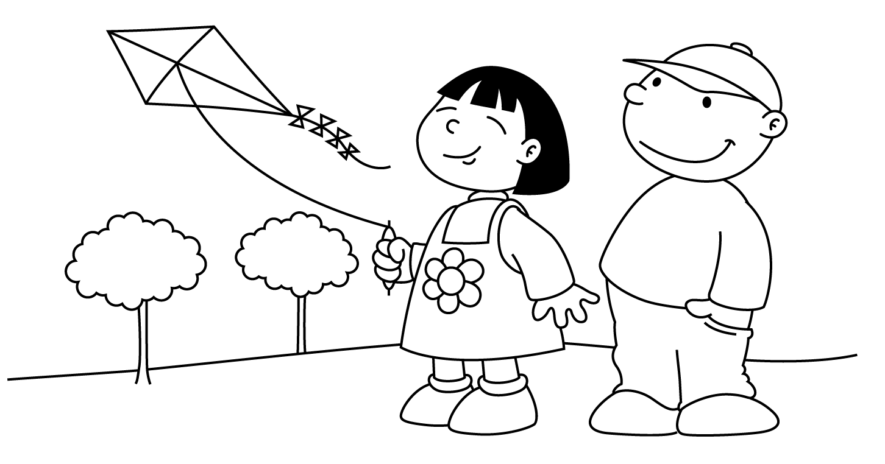

Student Life Calendar MARCH
Sunday | Monday | Tuesday | Wednesday | Thursday | Friday | Saturday
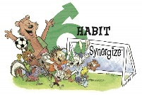 |  | 1 | 2  Speech Fest  1:15 | 3  Get Ready, Get Set, Read! | 4  Healthy Lunch Box | 5
6  Spirit Week | 7  Candyland/ Pyjama Day  Logan Ramsay | 8  Twister/ Clash Day | 9  Scrabble/ Initial Day  Junior SG Basketball | 10  The Game of Life/ Career Day  Healthy Lunch box | 11  Battleship/ Color House Day | 12
13  Time Changes | 14 | 15  Kira McIntosh | 16 | 17  Adam Bouma | 18  Samuel Visser | 19
20 | 21 | 22 | 23 | 24 | 25  Mr. Wicklam  Good Friday | 26
27  Easter Sunday | 28  Noah Harrison  No School | 29  Back to School! | 30  Easter Assembly  Lifetouch Grad Pics @ Studio | 31 | Habit 6: Synergize  I value other people’s strengths and learn from them. I get along well with others; even people who are different than me. I work well in groups. I seek out other people’s ideas because I know that by teaming with others, we can create better solutions than what any one of us could alone. I look for Third Alternatives

