Family REGISTRATION FORM:
Belleville Christian School SPIRIT RUN 2016 _________________________________________
(Family Name)
Saturday June 4, 2016 138 Wallbridge-Loyalist Rd. & Quinte Conservation Area
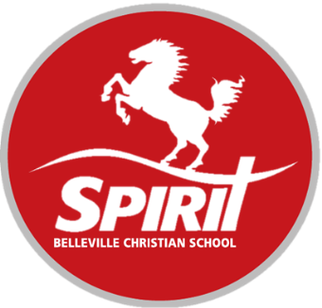
Sign In: 9:00 am Start Times: 2 km Kids: 10:00, 5 km Runners/Walkers: 10:30

Please fill out the following information and return to the office:
*Bring your pledge sheet and all collected money to the school by Friday, June 3, 2016. No money at race day please!
*Sponsors will be collected by FAMILY not by individual participants.
*A minimum pledge amount of $20 per FAMILY member to get free shirts
*Registration is due by May 20 to guarantee a free Spirit t-shirt.

Family Last Name: |  | Office Use:
Participant First Name: | T-Shirt Size: | Received:
Johnny | Youth S | 

I am not raising pledges but would like a t-shirt: Name: ____________________________ Size: ___________________ REC’D and PAID: ______
Tax receipts will be issued for $20 or more, but only if the donor’s name and address are clearly printed and complete on the pledge form. All pledges received on the pledge form for the above named FAMILY will go to Belleville Christian School. 20% of funds raised will be donated by BCS to the Canadian Cancer Society‘s Pedal for Hope Campaign which supports Pediatric Cancer Research.

Waiver of liability in consideration of my acceptance in the Belleville Christian School Spirit Run/Walk on June 4, 2016: I waive any and all liability for myself and my heirs against Belleville Christian School (hereinafter called BCS), and all the members of the Board, the Committee, the Staff and the Volunteers of BCS and the Run/Walk for any damages, injuries and or illnesses which may directly or indirectly result from my participation in the Run/Walk. I further state that I/my Child am/are in proper physical health to participate in this Run/Walk.

Signature: ____________________________________________________ Date: ____________________________________

